Day in the Life of the Hudson River 10/12/17 Data
(Salt Front ~ RM 65)
RIVER MILE 75
Fall Kill/Hudson intersection in Poughkeepsie, NY
Brent Boscarino 10th graders & Lynn Fordin 2nd graders, Poughkeepsie Day School
18 students 2nd, 9-12th and 8 adults
41º42’32.80”N and 73º56’25.19”
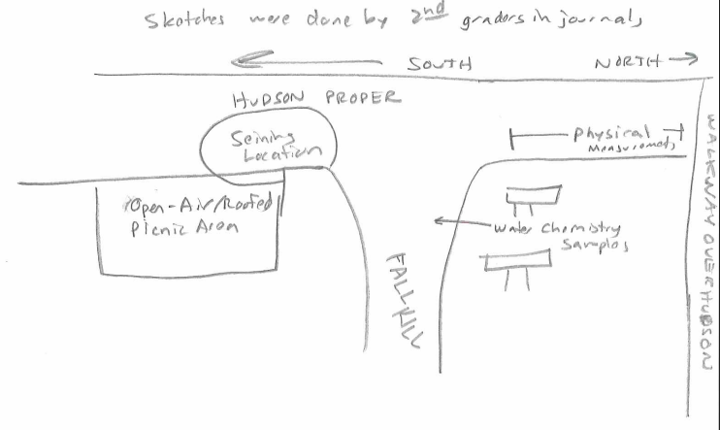
Location: Fall Kill/Hudson intersection
Surrounding Land Use: 50% rocky beach, 50% industrial/commercial
Sampling Site: rocky, some plants, small pipe north. Bottom was rocky, seeds from water chestnut
Plants in Sample Area: 30%
Shoreline: 35% riprap, 30% covered with vegetation, 10% debris, 25% other
River Bottom –sandy, muddy
Water Depth – 50cm
ITEM | Time | Reading 1 | Reading 2 |  | Comments
Physical
Air Temperature | 10:39  11:15 | 65.7ºF  67.5 | 19.4ºC  19.7
Wind Speed | North | 2.5 Beaufort force
Cloud Cover | 10:35 AM | overcast | 76-100%
Water | At beginning, there were white caps, but it settled down between 10:00-11:30
Weather | Got sunnier as time advanced
Water Temp. | 10:00 AM | 73ºF | 23ºC |  | .
Turbidity – long site tube |  | 43cm
Chemical
DO - Drop Count | 10:10 | DO 8mg/l | 92% saturation
pH – indicator sol.  Color match | 10:05 | 6.7  6.8  7.0 | Average: 6.9
Salinity - low range quantab | 10:30  2.6 | 0.011%NaCl | 68ppm Cl⁻ conc. |  | 115.62 ppm TS
Digitally, we got 279.8 us/cm using Vernir probes—conductivity
Fish Catch – 28 feet net | Number Caught | Species | Largest
Circle seine, 7 seines  7’ deep nylon, ½ inch sq mesh, 1 inch stretch, nylon seine, | 1  1  1  1  6 | Smallmouth Bass  Bluegill  Pumpkinseed  American Shad  White Perch | 15in  8  7  3  13 | 38.1cm  20.32  17.78  7.62  33.02 | DIV – 5  Catch - 10
Macroinvert | 4 | Amphipods
Tides | 9:45  10:00  10:15  10:30  10:45 | 53  40  34  27  25 | Falling  Falling  Falling  Falling  Falling |  | -.866 cm/min  -.40  -.46  -.13
Currents | 10:05 | 12.5 cm/sec | 0.999 Knots |  | South, Flood
The fall Kill enters the Hudson around 50-100 feet south of where the measurements were taken
Boating and Shipping | 9:35 | White | Southbound |  | Loaded
CORE | Condition | Rare | Common |  | Abundant
 |  | Clay  Leaves  Wood  Shells Oysters  Freshwater Mussels  Zebra Mussels  Macroinvertebrates | Mud  Sand  Gravel  Pebbles  Concrete  Brick chunks  Pipes?

